ASSIGNMENT 2- Connecting Data

Name: Padmapriya Palanisamy

* **Connect to the Store Sales Data**
* Removed Blank rows
* Column Header updated

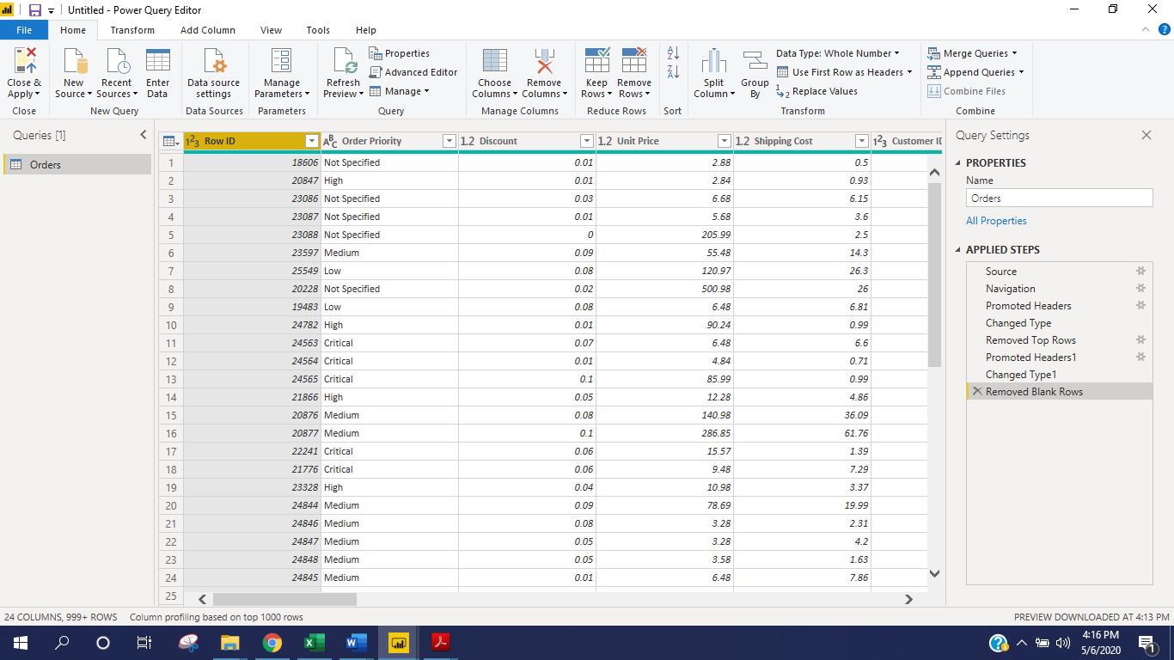

* **Create a text table and show the sales in terms of**
* Customers, Product Category, Regions

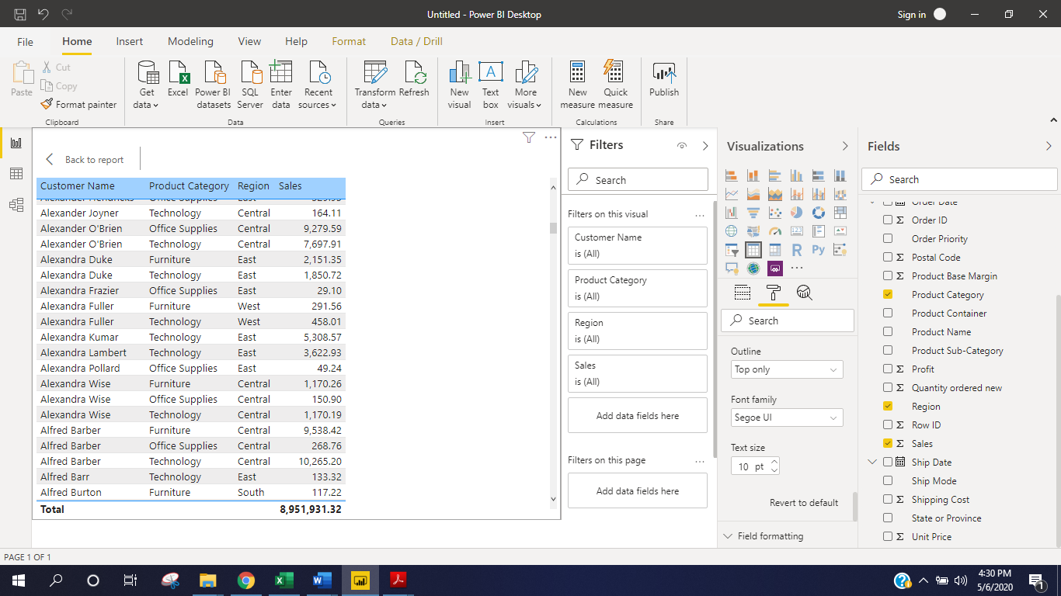

* **Create a line and Clustered Column Chart showing the Sales and Discount as per the State or Province**

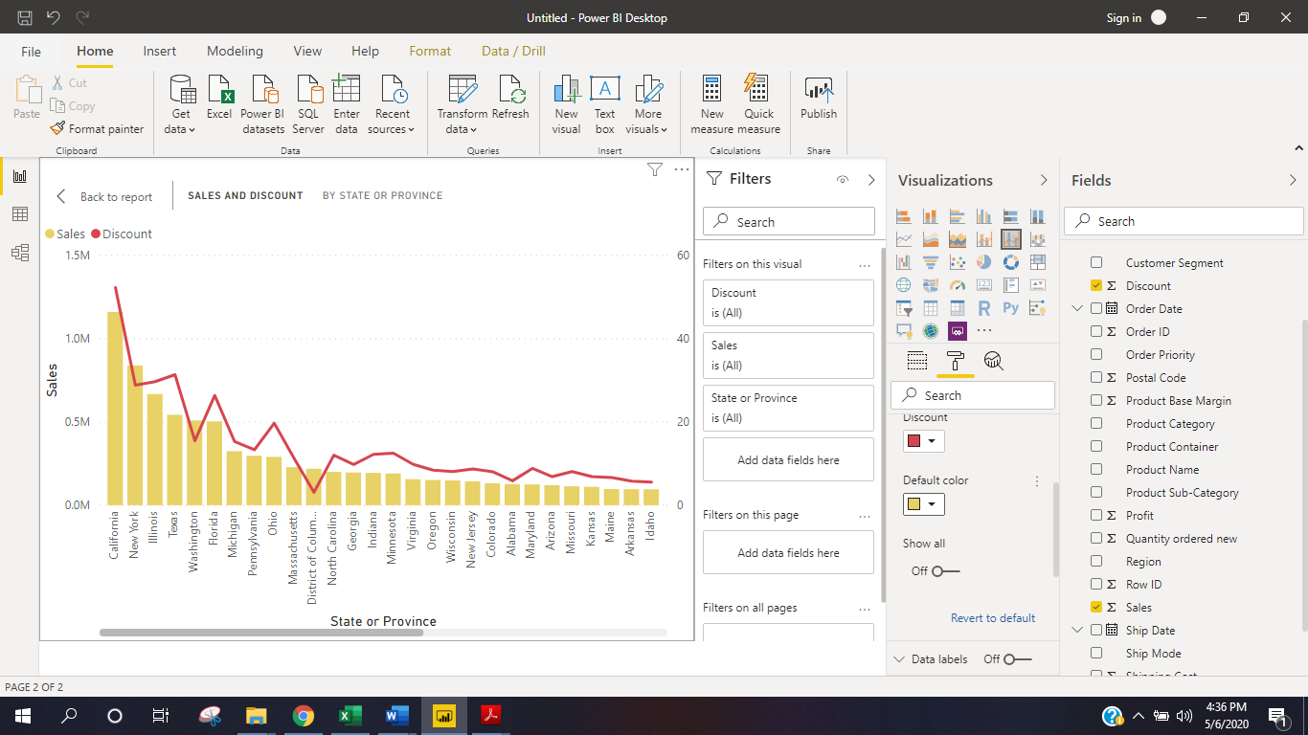

* **Create a Donut Chart showing sales in terms of Product category**

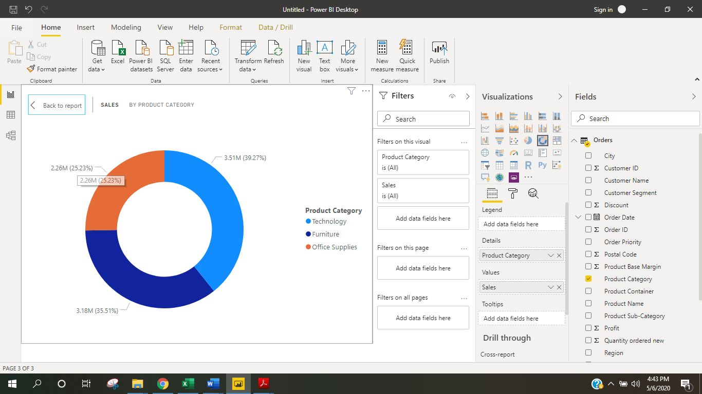

**Donut Chart with Card and Slicer**

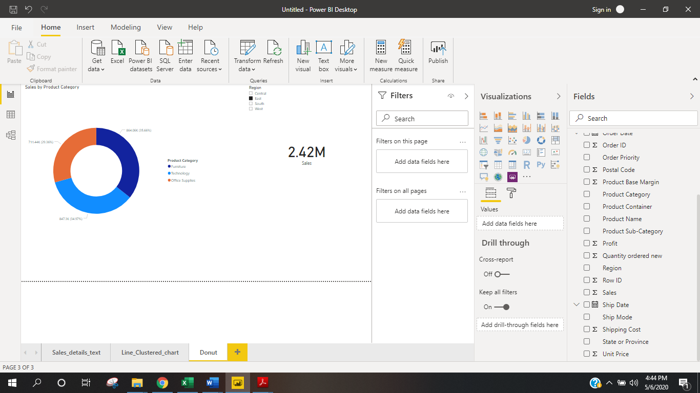

* **Create a** *Slicer* **and show the regions in dropdown. See how all the visuals mentioned above behaving when a particular region is selected**

Region Selected as **South – Visuals are changing as per the filters**

